BEAT Route Project Engagement Report

Prepared by Dr Neill Cooper, volunteer
Dr Adrianne Calsy, member of steering committee

9 January 2026

______________________________________________________________________________

Background
The BEAT (Barrow to Esk Active Travel) Route project is seeking to provide high quality and safe active travel routes for residents and visitors to get to where they need and want to go, with enjoyment. At present, the transport infrastructure of South West Cumbria does not meet those criteria.
Initial members of what became the BEAT Route project circulated a survey during summer 2023 in the Millom and Broughton areas to understand what journeys residents made, how they travelled, what discouraged and what would encourage them to travel actively. The responses to this survey showed a clear desire in the community for the creation of active travel routes and led to the formation of the BEAT Route project. The project was initiated through community stakeholder meetings from early 2024 to involve parish council representatives, ward councillors, others with interest in active travel and the then MP for Copeland, Trudy Harrison.
Further information on the BEAT Route project is provided in the ‘BEAT Route Strategy Report’.
Survey 2025
In summer 2025 the BEAT Route project attended local events including Thwaites Gala, an annual fundraising sale at Kirksanton, Kirkby in Furness Gala, Black Combe Country Fair, and Millom and Broughton in Furness Show.
BEAT Route members spoke to residents about the project, collected support for the principle of the project, and circulated a survey to further understand residents’ views on active transport.
Of 350 + survey respondents over 90% said they relied on private, motorised transport for travel in their local area. With this level of reliance on private cars the area becomes ‘motornormative’- there is an unconscious cultural assumption that driving is the default mode of travel.
‘Children in my small community gleefully cycle in front of and between houses but never go anywhere by bike because the narrow rural lanes are not considered safe. When they get older and go to work/higher education they take the train – via a lift to the station 2 miles away – and then immediately seek to purchase a car for the journey to Barrow in Furness, never again to appear on a bike’. (Millom Without resident)
However, 60% of the respondents said they would travel more by active modes (walking, wheeling, cycling, horse riding) if safe, traffic-free routes were available to them.
The survey asked for respondents to rate the quality of the provision for active travel in the South West Cumbria. Of those who responded 70% rated the area provisions as poor or very poor. Statements from the surveys highlight the need for these routes:
- ‘I feel safer cycling in London than I do on lanes near my home’ (Broughton in Furness resident)
- [We need….]‘Safe cycle lanes that feel safe with a child seat/trailer’ (Askam resident)
- ‘We’ve stopped using our bikes as we’ve had too many near misses; it is too dangerous’ (cyclists who travel between Bootle, Millom and Askam)
- ‘I have a bike but don’t want to use in my area but do cycle when I am abroad’(Millom Without resident)
- ‘I’ve 2 children who enjoy their bikes but I don’t want them to cycle on the roads because of dangerous driving’ (Millom Without resident)
- From the Millom disability group ‘Many of our families rely on wheelchairs, mobility scooters, pushchairs or other mobility aids. The current lack of suitable, traffic free footpaths often restricts our ability to participate in the mental and physical health benefits of being outdoors. Accessible, traffic free routes would provide a safe space for exercise and socialisation, fostering greater independence for disabled individuals and their carers’
Further, 60% of respondents highlighted the need for links to public transport, indicating a general desire to shift away from high reliance on cars for journeys. Reflecting the general lack of travel infrastructure in Cumbria a number of respondents highlighted the difficulty in travelling to areas they wanted or needed to go.
- ‘Cycling 10 miles on busy A roads with difficult hills to get to a village 2 miles away’ (Waberthwaite resident)

- The only place in England where the coast path is the train! (the English Coastal path crossings of the Esk and Duddon rivers are by train) (Millom resident)
While at the shows the BEAT Route project provided a map, as an alternative to completing a survey, for people to indicate where they lived, travelled, and found active travel hazardous. The map from Millom and Broughton in Furness show (pictured) shows very clearly several areas considered to be hazardous for active travel (red pins). For these sections of the route it is notable that there are no alternatives to the busy main roads highlighted. This is further evidence of residents’ need for safe, traffic-free, active travel routes.
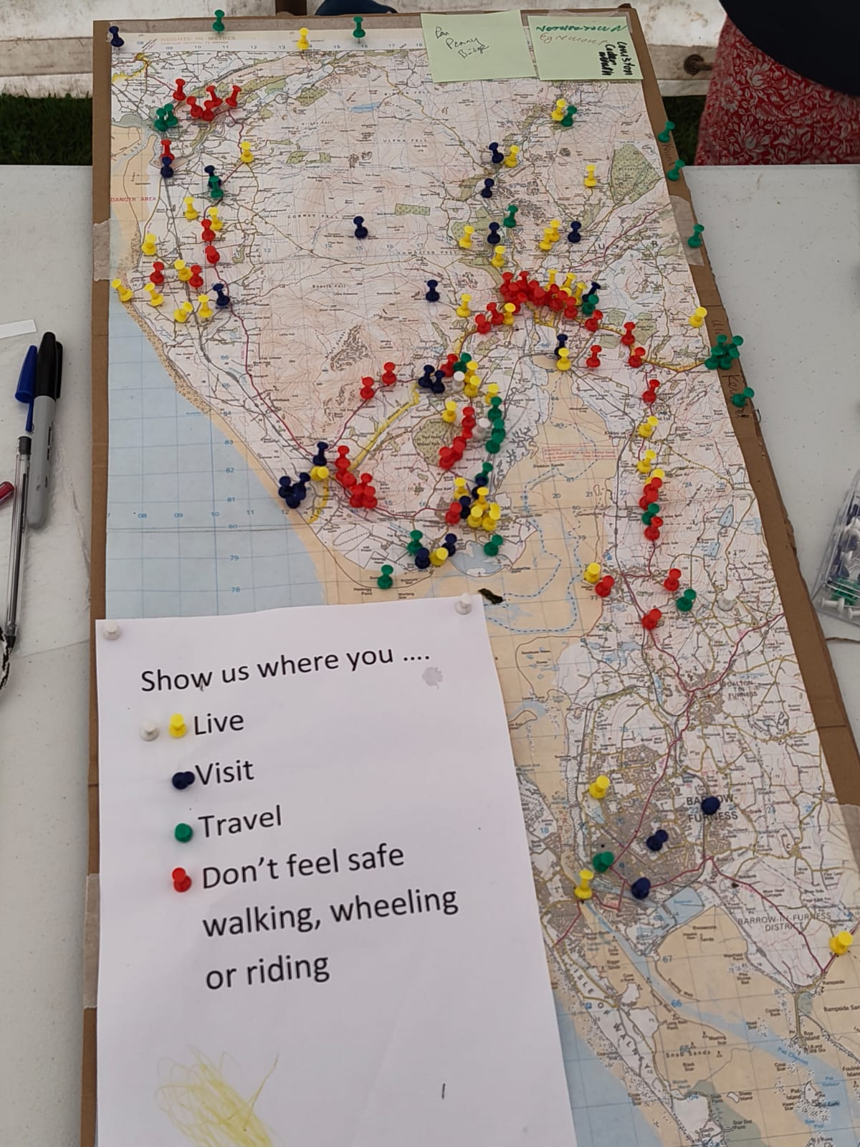
Further evidence of support
Extracts from letters of support:
Local business, The Wayside and Whiskey barn: ‘As a local accommodation and hospitality business we see first-hand how better active travel connections can strengthen our communities and the visitor economy’
Lake District National Park Authority, in the context of preparing an Active Travel Network Plan for the Lake District, highlighted that ‘the Barrow in Furness to Esk route received a high level of community support and has a good strategic fit, plus the proactive community group developing the route was a really positive factor. As a result, the BEAT Route was identified as a priority route, giving it a strategic support and a higher priority should funding become available’
From a local cycling group, Millom Velo: ‘Riding on local roads is hazardous with some areas extremely busy with traffic, especially in the summer season…the BEAT Route project would provide a safe environment for cycling, especially for the junior riders’
From Waberthwaite School ‘We would love our children and their families to be able to enjoy the fruits of the BEAT Route project and believe it has the potential to deliver significant benefits’
From the Millom ward councillor ‘Having seen the positive engagement of the project with the local community at Millom and Broughton in Furness Show at the end of August this year I am confident there is strong support for safe active transport’
From South Copeland Partnership (of Parish Councils): ‘The current connection [for Cumbrian Coast communities] is the A595/A5093 which has significant dangers for all transport means and particularly for those with low protection to the traveller. This will act as severe discouragement to active travel and its associated markets which can benefit the local economy’.
From a senior social prescribing officer for Cumberland: ‘We know that this development will open up opportunities and improve loneliness, isolation, mental health and physical wellbeing …this initiative will benefit so many people’
From Millom Town Deal: ‘We see the benefits of connecting Millom and Haverigg to a wider network which delivers both health and economic benefits to a broader area of South Cumberland’

Other routes in the area
A number of residents have highlighted the desirability and popularity of routes in other parts of Cumbria. These include:
The Bay Cycle Way (National Cycle Network Route 700) from Barrow to Heysham (see Millions using Morecambe Bay cycle way)
The C2C (National Cycle Network Route 7) from Whitehaven to Tynemouth, the UK’s most popular cycle route. See https://www.walkwheelcycletrust.org.uk/our-blog/national-cycle-network-route-collections/the-uk-s-best-long-distance-cycle-rides/
Hadrian’s Cycleway (National Cycle Network Route 72) from Bowness on Solway to Tynmouth is highlighted as family-friendly and easier route than the C2C. Note that work is ongoing to reinstate and improve sections of the route which formerly started at Ravenglass.
The W2W (National Cycle Network Route 70), a more challenging East/West route from Walney to the Wear or Whitby.

Residents have noted that with the lack of public/active transport in this area young people can struggle to gain travel independence due to lack of driving instructors, distance from test centres (Barrow in Furness or Workington) in addition to the cost of a car, insurance, and fuel.

